**Bulk Upload and Data Validation System Documentation**

**Introduction:**

This document outlines the design and functionality of a web-based application developed for managing bulk uploads and data validation. The system facilitates users to register, authenticate, upload claim forms in bulk, map data fields, validate data, and view the inserted data.

**System Overview:**

The system is designed to streamline the process of uploading and managing large volumes of claim forms. It provides a user-friendly interface for users to upload claim forms in bulk, map fields, validate data, and view the imported records. The system ensures data integrity and accuracy through comprehensive validation checks.

**Features:**

**1. Authentication and Registration Form:**

- Users can register with the system by providing necessary details.

- Secure authentication is implemented using JWT tokens.

- Upon successful registration, users are authenticated to access other features.

**2. Bulk Upload Form:**

- Users can upload claim forms in bulk via CSV.

- An Excel template is provided for download.

- Each claim form includes the following fields:

- Name *

- Reference ID (auto-generated during bulk upload)

- DOB*

- Gender

- Contact Details

- Country *

- Accident Information *

- Venue

- Date & Time

- Visit Date & Time

- Total Cost *

- Users can upload a minimum of 5 to 500 records per file.

**3. Field Mapping:**

- Upon uploading the file, users are directed to a field mapping screen.

- Columns are automatically mapped, and users can manually map columns to corresponding database fields.

**4. Data Validation:**

- After mapping, users are directed to a validation screen.

- The system validates the data for errors, including:

- Number of records skipped due to issues

- Identification of unmapped fields

- Validation of mandatory fields and detection of empty or incorrectly formatted fields

- Errors are displayed for user review.

**5. Data Import:**

- Upon successful validation, users can import the data into the system.

- A success message is displayed upon import completion, along with the number of records added.

**6. View Inserted Data:**

- Users can view all inserted data within the system.

- Deletion of records is supported with a confirmation message and success feedback.

**Technology Stack:**

- Backend: **NodeJS**

- Frontend: **React**

- Database: **MongoDB**

- Authentication: **JWT (JSON Web Tokens)**

**Screenshot:**

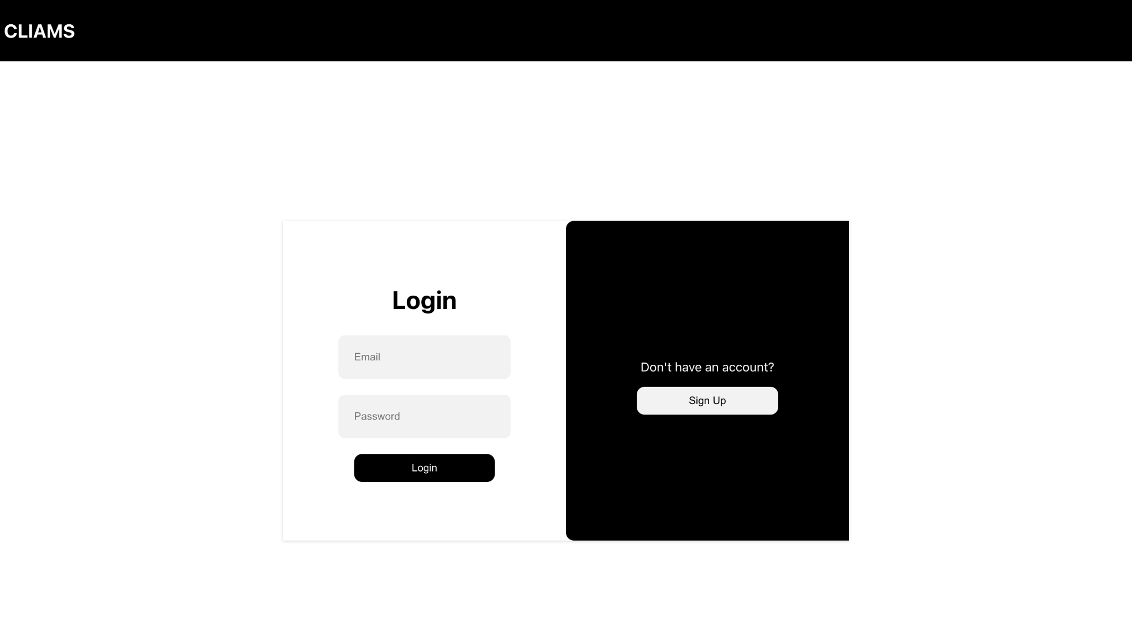

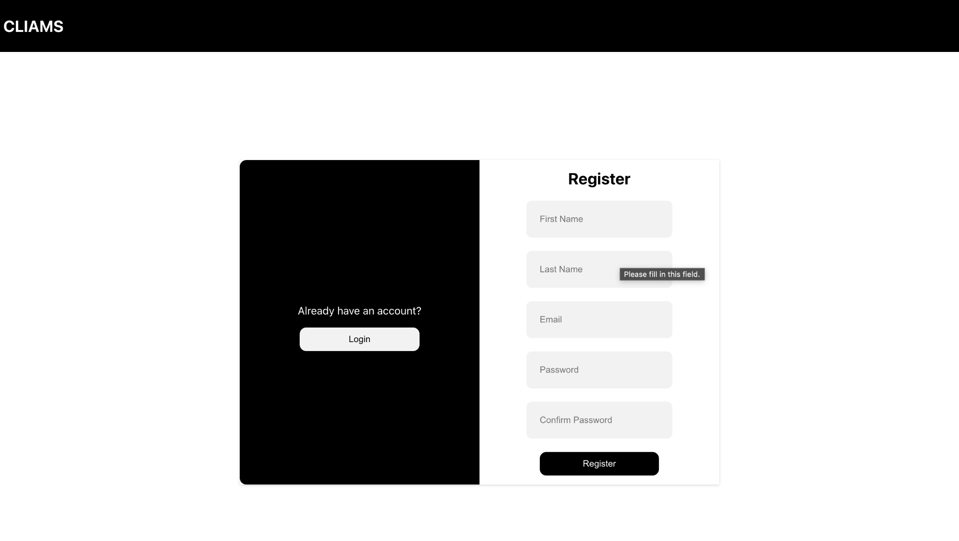

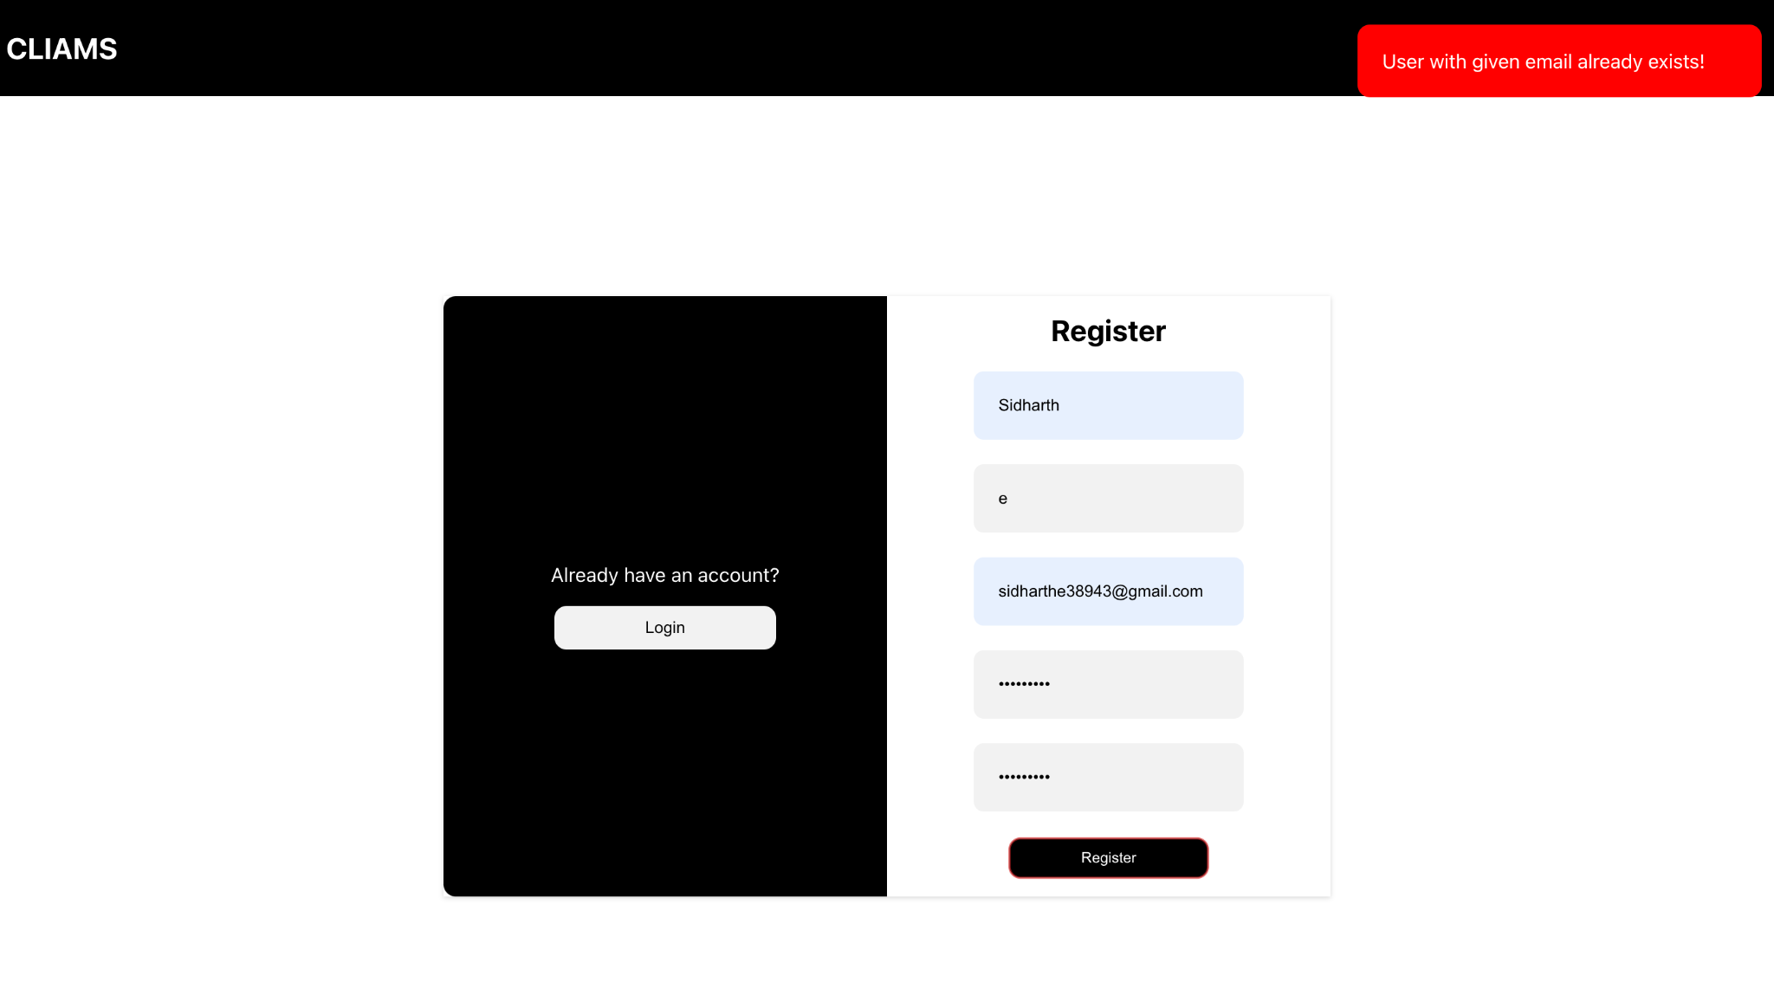

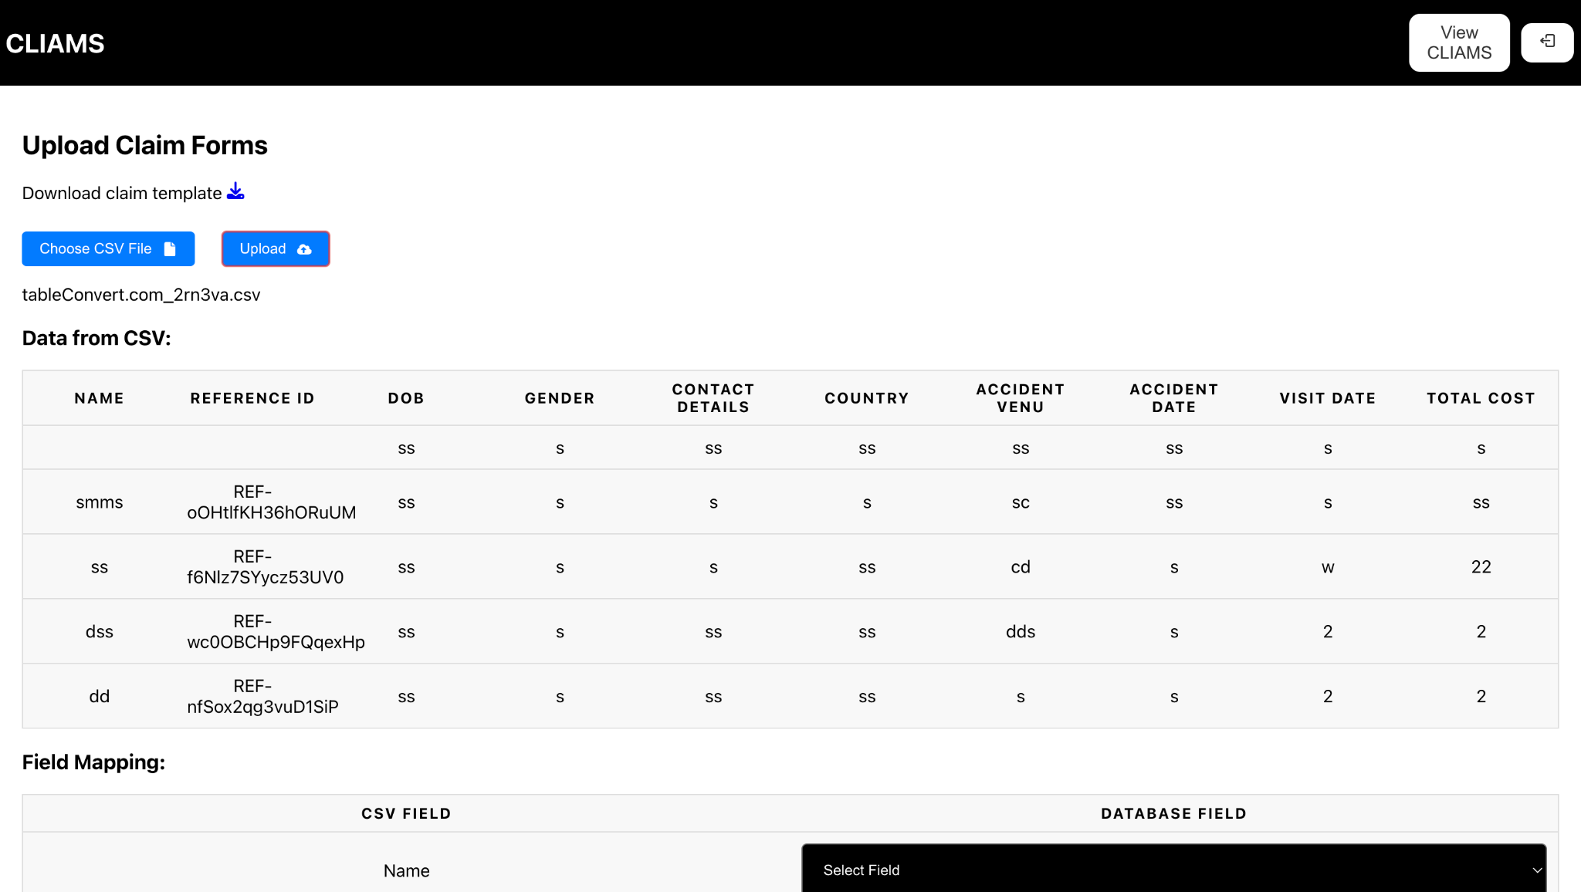

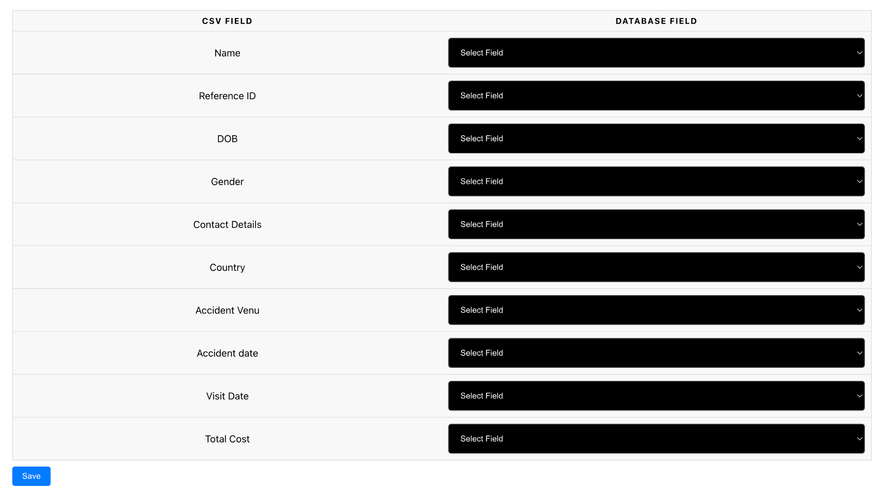

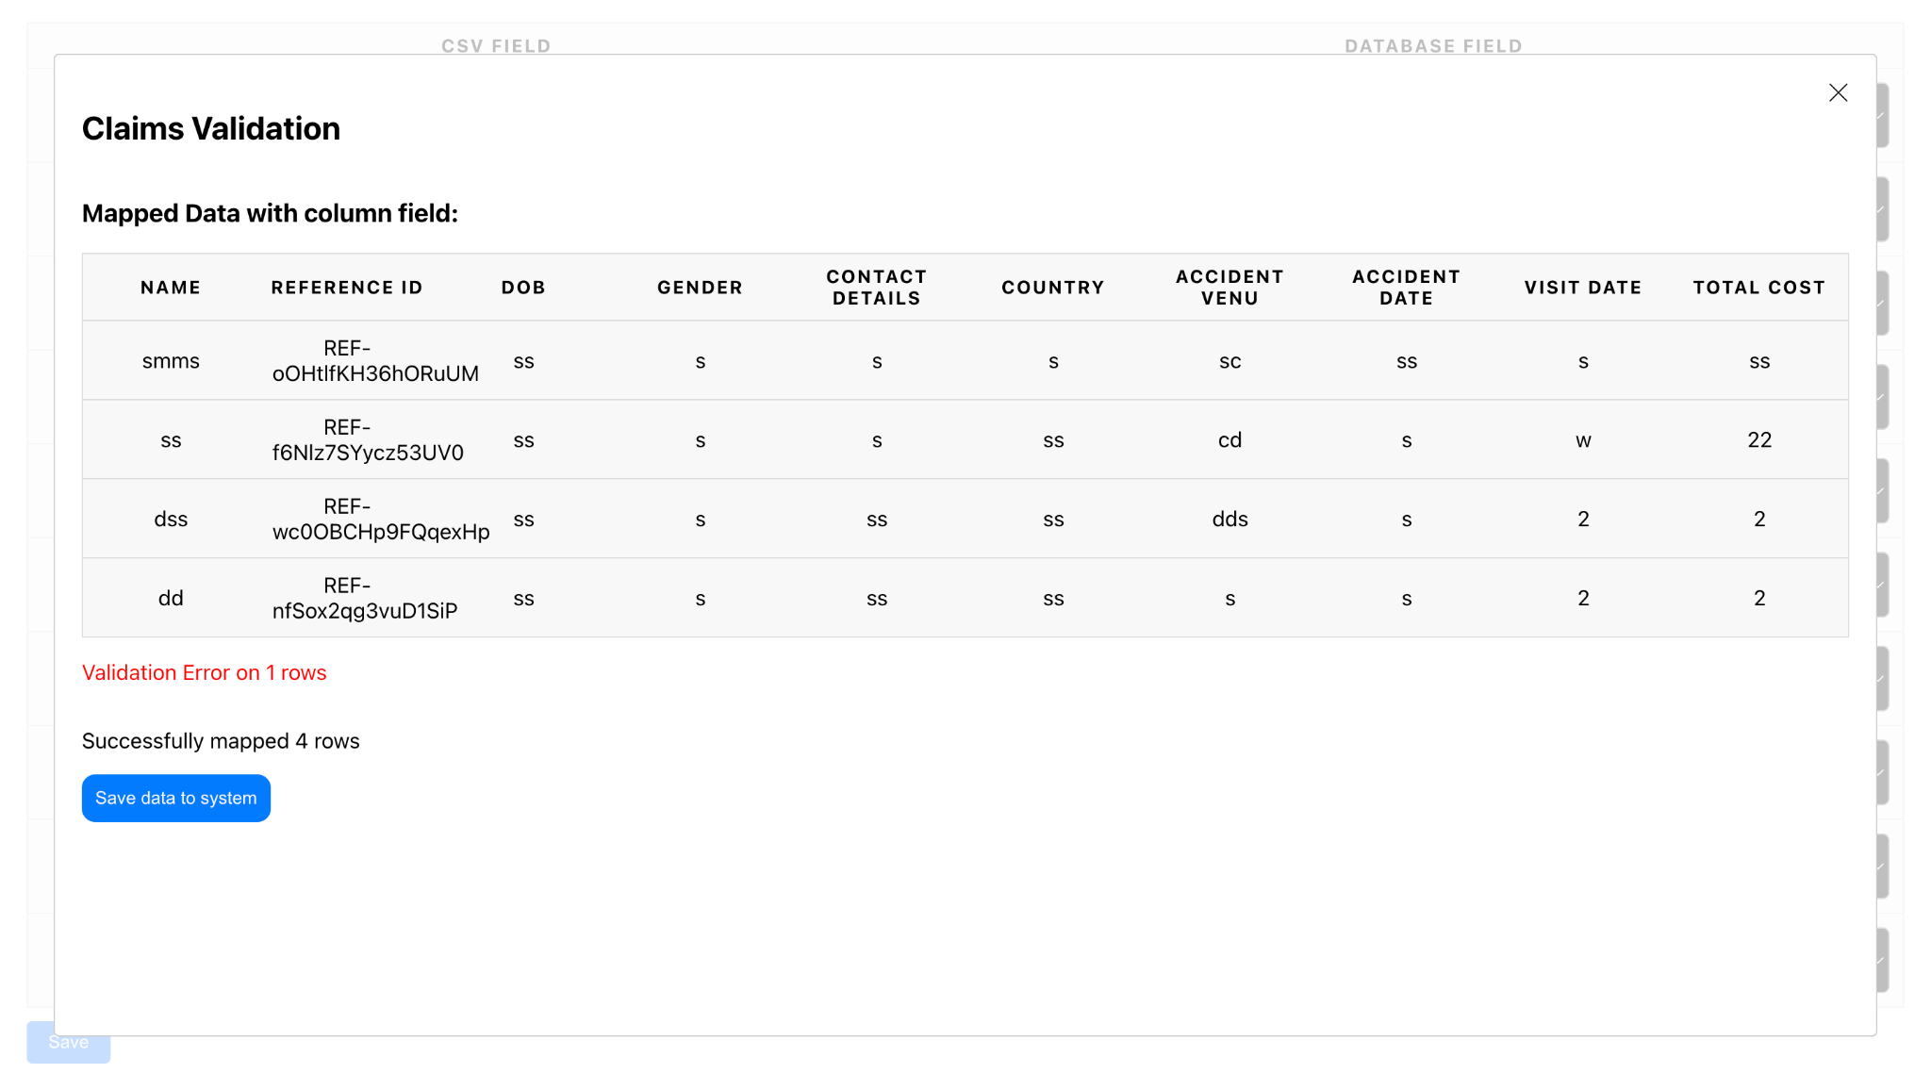

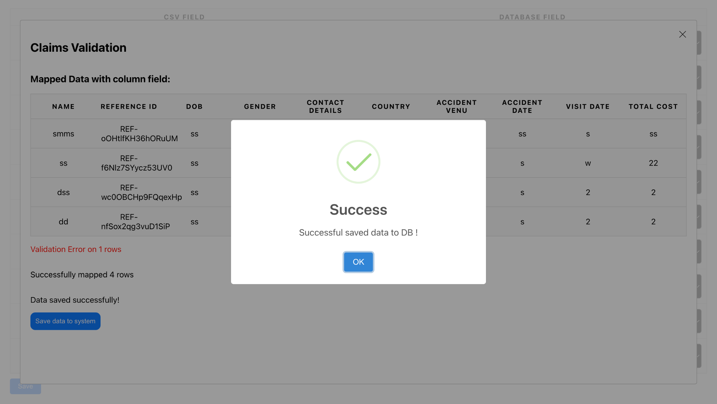

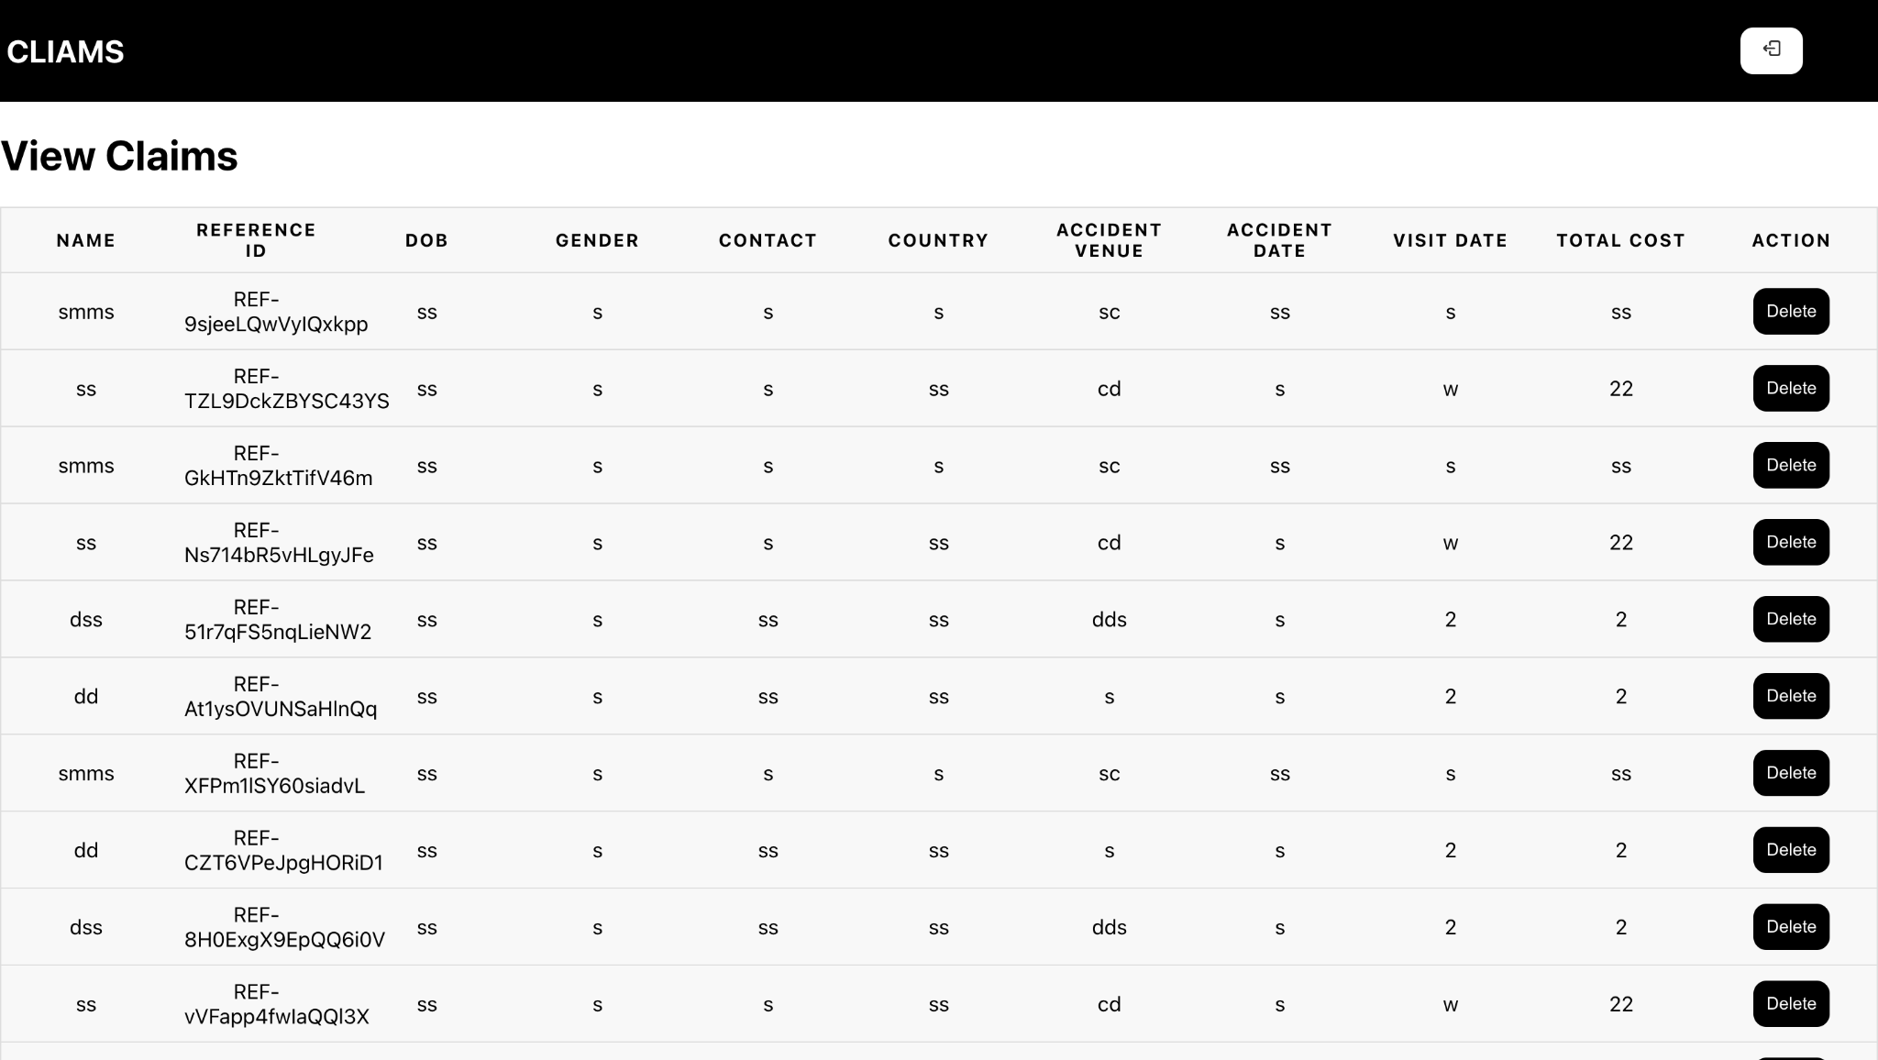

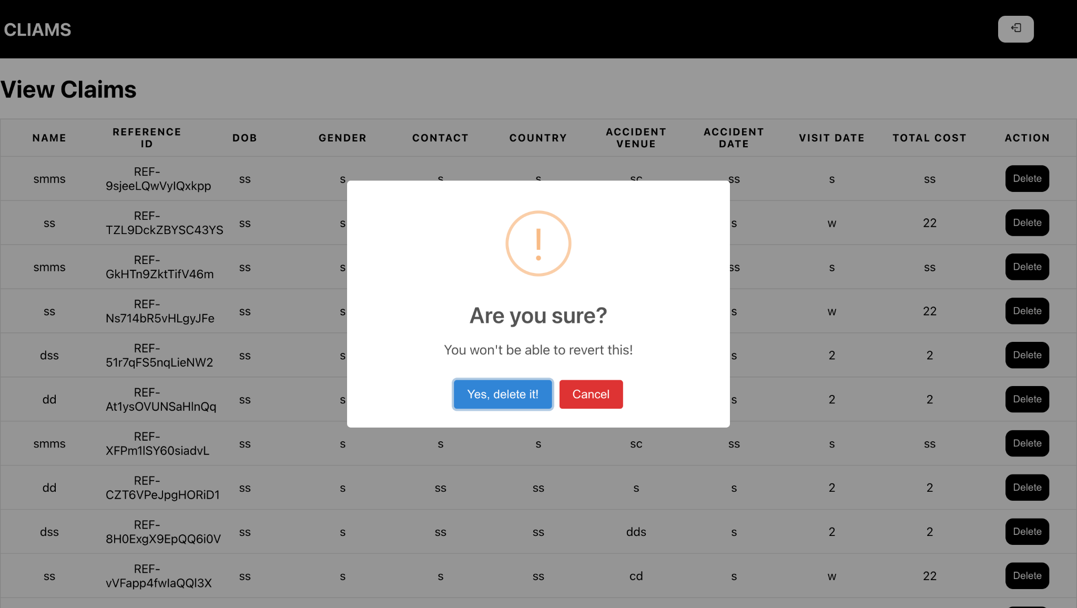

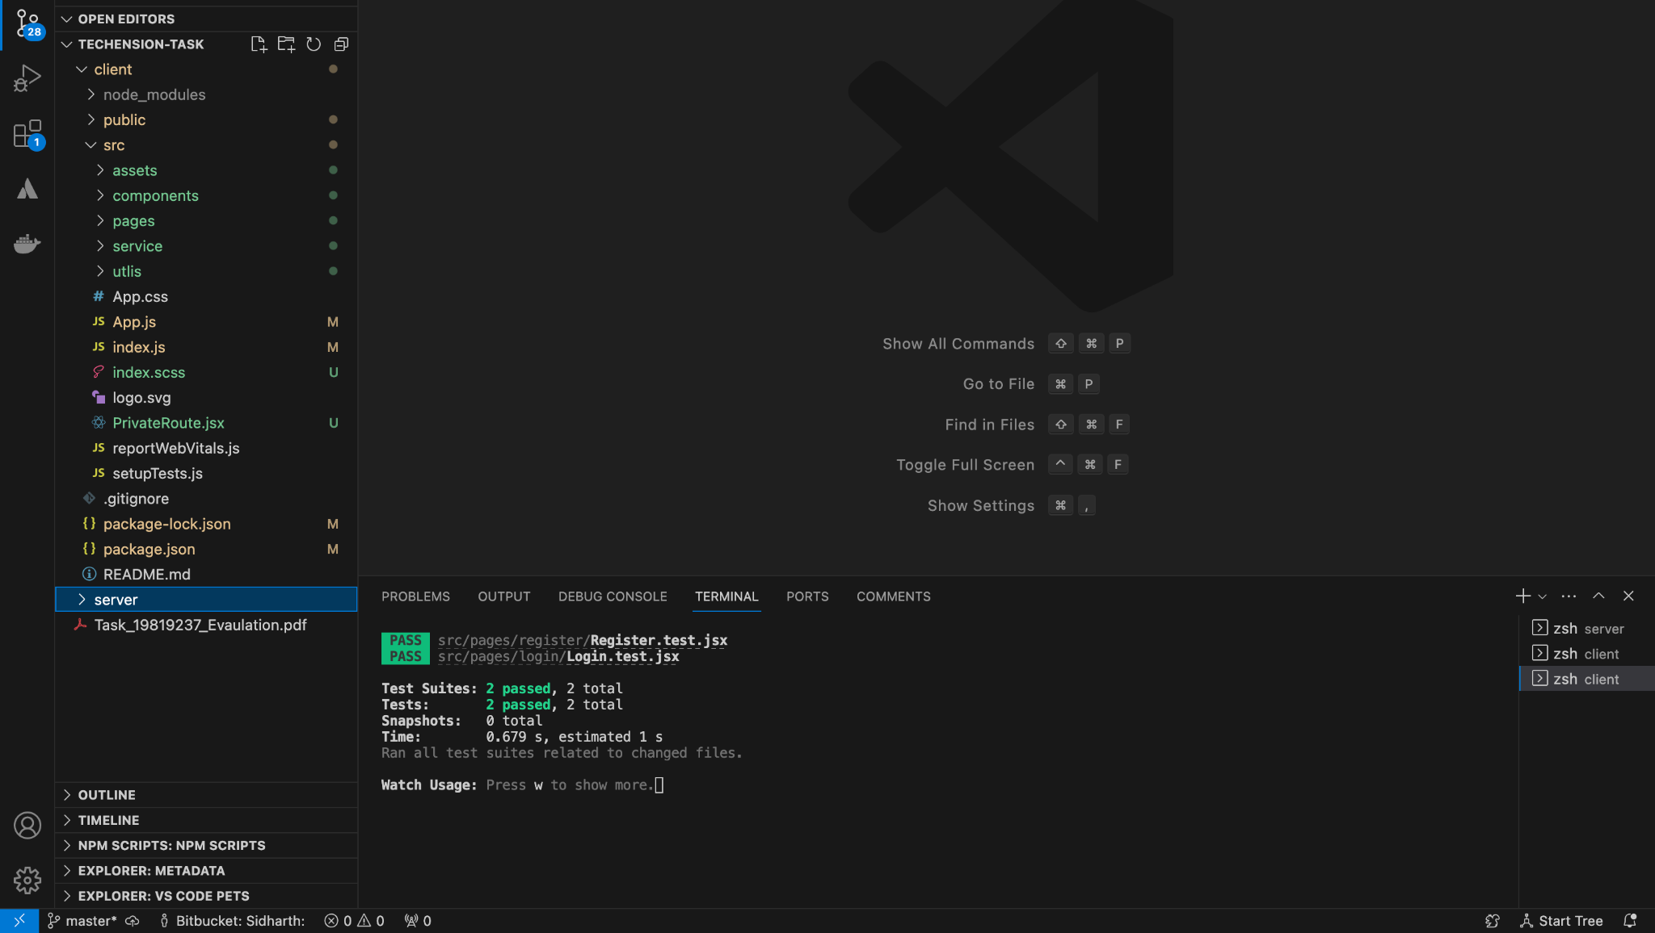

**Project Structure:**

**Frontend:**

**project/**

**│**

**├── src/**

**│ ├── assets/ # Images, fonts, etc.**

**│ ├── components/ # Reusable components**

**│ ├── pages/ # Components that represent entire pages**

**│ ├── services/ # API calls, utility functions**

**│ └── utils/ # Helper functions, constants, etc.**

**│**

**├── public/ # Static files like HTML, favicon, etc.**

**│ ├── index.html**

**│ └── ...**

**│**

**├── package.json # Project dependencies and scripts**

**└── ...**

**Backend:**

**project/**

**│**

**├── middleware/ # Middleware functions**

**│**

**├── models/ # Database models**

**│**

**├── routes/ # Route handlers**

**│**

**├── db.js # Database configuration**

**│**

**├── index.js # Entry point of the application**

**│**

**└── ...**

**Conclusion:**

The Bulk Upload and Data Validation System streamlines the process of managing large volumes of claim forms. It provides a comprehensive solution for users to upload, validate, and manage data efficiently. With secure authentication and robust validation checks, the system ensures data accuracy and integrity.